Question2.

The stored procedure implemented for this question verifies every borrowed book and if the return_date is smaller the current date the overdues_fees are increased depending on the type of member (student +0.35 ,teacher +0.5 ,

other + 1.5)

Before running the stored procedure (date 03/18/2013)

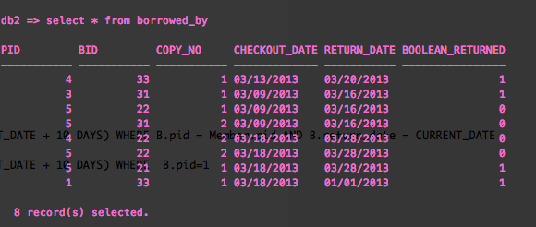

The above query shows that member with pid 5 has 2 late books, pid 1 and pid 3 has 1 late book.

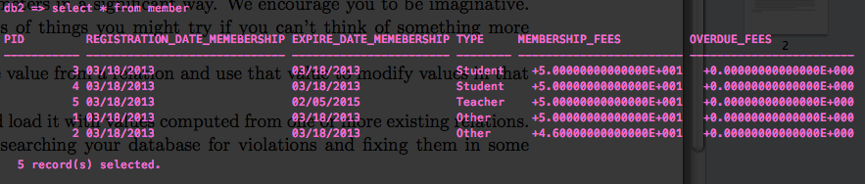

The above query shows the overdue_fees of members (pids)

After running the stored procedure

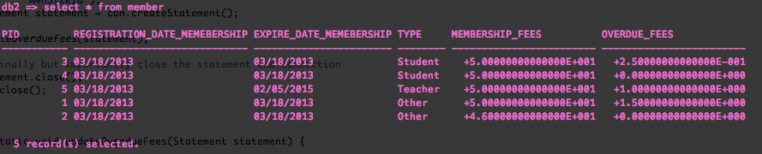

The above query shows the increase in overdue_fees of members with overdue books

Pid 5 is a teacher (+0.5) and had 2 overdue books: 2*0.5 =1.0

Pid 3 is a student (+0.25) and had 1 overdue book: 1*0.25 = 0.25

Pid 1 is another type (+1.50) and had 1 overdue book: 1*1.50 = 1.50

Question 1.

When a new book is borrowed if the return_date of the book is set to default this trigger will automatically update return_date to 10 days after.

CREATE TRIGGER set_return_date

AFTER INSERT ON Borrowed_by

REFERENCING NEW as n

FOR EACH ROW

WHEN (n.return_date = CURRENT_DATE)

UPDATE Borrowed_by

SET return_date = (CURRENT_DATE + 10 DAYS)

WHERE pid = n.pid AND bid = n.bid

3

The following query shows that if we insert a book with default retun_date date which is the current date, the trigger will modify the return_date to be (current date +10 days)

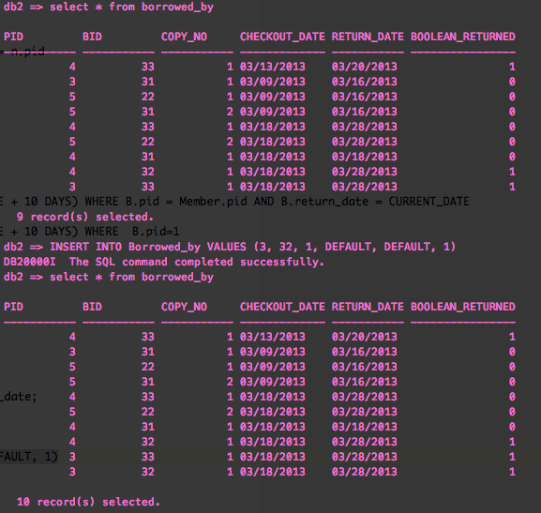

The following query shows that the return_date is not updated since the inserted return date is not the curent date , therefor trigger does not run

